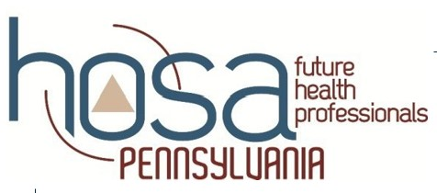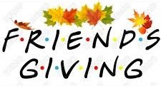

Join the global movement & attend a free DEMENTIA FRIENDS virtual information session. The session will cover the 5 Key Messages about Dementia and touch on how to help a person living with Dementia.

November 14, 2025--8:30-9:45 or 12:30-1:45
November 17, 2025--8:30-9:45 Or 1:30-2:45
Please email asprankle@goodnewsconsulting.com
to register your classroom.
