2026 PENN HOSA
State Leadership Conference
PIN PREORDER
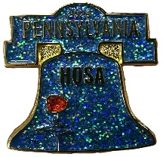
Liberty Bell Pins sparkle and have a swinging clapper.
PreOrder - $5/each At SLC - $7/each

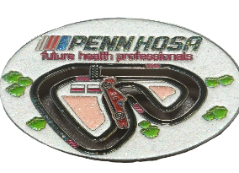
Nascar Pins have a RaceCar that slides around the entire track.
PreOrder - $8 each At SLC - $10/each

Please mail this Form with Check by 3/1/25.
PreOrdered Pins will be ready with your SLC Registration Packets.

Chapter # ______________Chapter Name/School__________________________
Advisor Name _______________________________________________________

Liberty Bell Pins _____________ x $5/each = ____________________________
Nascar Pins _____________ x $8/each = ____________________________
Total Due $ _______________________________
Checks should be made payable to PENN HOSA
And sent to 432 W Springettsbury Ave
York, PA 17403

